FIRST PRESBYTERIAN CHURCH
OF GREENWICH
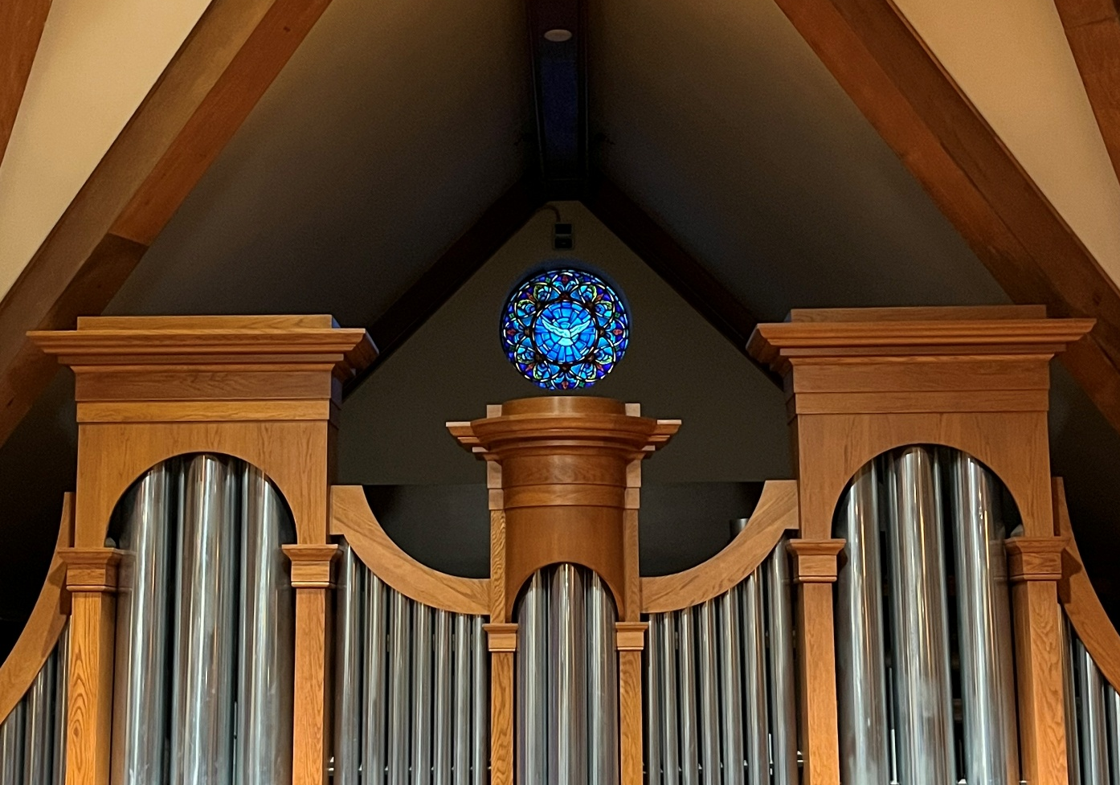

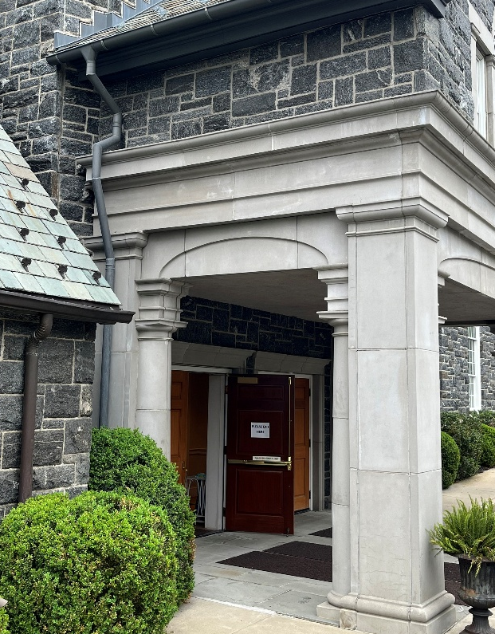
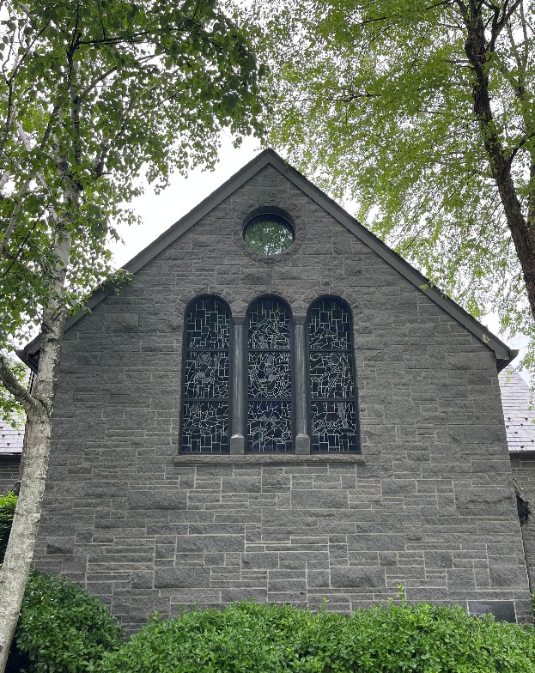

Pentecost Sunday
May 24, 2026
10:00 AM

Wherever you are on life’s journey, you are welcome here—with whatever joys, questions,
or tears you bring today—
as we worship God,
who welcomes us all!
You are invited to listen
for God’s Spirit speaking
through the music of the Prelude
as we prepare our hearts for worship.

ORDER OF WORSHIP
PRELUDE |  |  |  |  | Thee We Adore, O Blessed Savior |  |  |  |  |  |  |  | Healey Willan
WELCOME
*CALL TO WORSHIP
 | One: |  |  | When the Feast of Pentecost came, they were all together in one place.  Without warning, there came a sound like a strong wind, gale force;  no one could tell where it came from. It filled the whole building.
 | All: |  |  | Then, like a wildfire, the Holy Spirit spread through their ranks,  and they started speaking in many different languages, as the Spirit prompted them.
 | One: |  |  | The love of God has been poured into our hearts through the Spirit given to us!
 | All: |  |  | This the day that God has made! We will rejoice and be glad in it!
*HYMN 289 |  |  |  |  |  |  | On Pentecost They Gathered |  |  |  |  | MUNICH
*CALL TO CONFESSION
*Litany of Praise and CONFESSION
 | One: |  |  | Holy Spirit, Creator, in the beginning your wind moved over the water.
 | All: |  |  | From you all creation draws life, and without you, turns to dust. Come, Holy Spirit!
 | One: |  |  | Holy Spirit, Counselor, your breath empowered prophets and apostles to act in faith.
 | All: |  |  | You gave them a voice to bear your Word to all the world. Come, Holy Spirit!
 | One: |  |  | Holy Spirit, Sanctifier, you call us to be children of God.
 | All: |  |  | With your gifts of love, you strengthen and send us to renew life in all creation.  Yet often, Living God, we hold back the force of your Spirit among us.  We don’t always hear your words of grace or speak and act your good news of love. Liberate us with a burning desire to live faithfully for the sake of Jesus Christ.  ~ Prayer continues in silence. ~
*ASSURANCE OF FORGIVENESS
 | One: |  |  | Jesus proclaimed God’s reign and was crucified. God raised Jesus and redeems all creation. Trust in God, the Holy Spirit, who frees us to accept ourselves and to love God and neighbor. The Spirit binds us together with all believers in the body of Christ, the church.
 | All: |  |  | We belong to God! With believers in every time and place, we rejoice that loving in life or in death can separate us from God’s love in Jesus Christ!
 | One: |  |  | The same Spirit who inspired prophets and apostles claims us in the waters of baptism and calls us all to ministry in the church. In a broken and fearful world, the Spirit gives us courage to work with others for justice, freedom and peace.
*RESPONSE OF PRAISE GLORIA PATRI
Glory be to the Father, and to the Son, and to the Holy Ghost;
as it was in the beginning, is now, and ever shall be, world without end. Amen, Amen.

*PASSING THE PEACE OF CHRIST
TIME FOR YOUNG DISCIPLES
SACRAMENT OF BAPTISM
Alexander Bernard Roesler
Arthur Mathewson Niehaus
Marcus Christopher Niehaus
(Children of Bernard Thomas Roesler, Emily Niehaus Roesler & Elizabeth Lorene Niehaus)

Presentation Liz James, Elder
Thanksgiving over the Water
Baptism
Welcome

PRAYER FOR ILLUMINATION
 | All: |  |  | Holy God of power and grace, fill us with the wisdom of your Word and the understanding of your Spirit. So may we be your church: a people with dreams and visions at work in the world; through Jesus Christ, our Lord. Amen.
SCRIPTURE |  |  |  |  |  |  | John 20:19-23 |  |  |  |  | p. 115 NT
ANTHEM |  |  |  |  |  |  | I Feel the Spirit |  |  |  |  | Traditional Spiritual  Arr. Nancy Price and Don Besig
There’s a little wheel a-turnin’ in my heart, ‘cuz the Spirit of the Lord is in my heart.
I’ve found the Spirit, I’ll never let it go. I’ve found the Spirit, I need to let it show.
I’ve found the Spirit, I want the world to know that the Lord is in my heart.
Everytime I feel the Spirit movin’ in my heart I sing with praise!
Glory Hallelujah! There’s a little song a-singin in my heart,
‘cuz the Spirit of the Lord is in my heart.

SCRIPTURE |  |  |  |  |  |  | Acts 2:5-21 |  |  |  |  | p. 119 NT
 | One:  All: |  |  | For the Word of God in Scripture, for the Word of God among us,  for the Word of God within us, alive in our hearts,  Thanks be to God.
SERMON |  |  |  |  |  |  | Language of Liberation  “And how is it that we hear, each of us,  in our own native language?” (Acts 2:8)
*AFFIRMATION OF FAITH |  |  |  |  |  |  |  |  |  |  |  | The Apostles’ Creed
 | All: |  |  | I believe in God, the Father almighty, creator of heaven and earth.  I believe in Jesus Christ, God's only Son, our Lord  who was conceived by the Holy Spirit, born of the Virgin Mary,  suffered under Pontius Pilate, was crucified, died, and was buried;  he descended to the dead.  On the third day he rose again;  he ascended into heaven, and is seated at the right hand of the Father,  and he will come again to judge the living and the dead.  I believe in the Holy Spirit,  the holy catholic church, the communion of saints, the forgiveness of sins,  the resurrection of the body, and the life everlasting. Amen.
HYMN 280 |  |  |  |  |  |  | Come, O Spirit, Dwell Among Us |  |  |  |  | EBENEZER
OFFERING
Ritual of Friendship: Please sign the red fellowship pad in your pew and pass it to your neighbor.
OFFERTORY DUET |  |  |  |  |  |  | The Gift of Love |  |  |  |  | Hal H. Hopson
Though I may speak with bravest fire, and have the gift to all inspire,
but have not love my words are vain, as sounding brass, and hopeless gain.
Though I may give all I possess, and striving so my love profess,
but not be given by love within, the profit soon turns strangely thin.
Come Spirit, come, our hearts control, our spirits long to be made whole.
Let inward love guide every deed; by this we worship, and are freed. Amen.

*DOXOLOGY
Praise God, from whom all blessings flow; Praise God, all creatures here below.
Praise God above, ye heavenly host; Praise Father, Son and Holy Ghost. Amen
*PRAYER OF DEDICATION
 | All: |  |  | Gracious God, for all your gifts, both seen and unseen, we give you thanks. May our offerings be acceptable in your sight; a mere portion of what you have so generously given to us. We pray that you would do more with them than we could ever ask or imagine. In Christ’s name we pray, Amen.
*HYMN 291 |  |  |  |  |  |  | Spirit, Spirit of Gentleness |  |  |  |  | SPIRIT
*CHARGE AND BLESSING
CHORAL RESPONSE |  |  |  |  |  |  | “Amen” from Jubilate Deo |  |  |  |  | Benjamin Britten
POSTLUDE |  |  |  |  |  | Fantasia Super: Komm, Heiliger Geeist, BWV 651 |  |  |  |  |  |  |  | J.S. Bach
*We are invited to rise together in God’s Spirit.

WELCOME!
We are delighted you are joining us in worship! Founded on Easter Sunday in 1881, First Presbyterian Church of Greenwich embraces our mission to nurture and empower people in all stages of life to be Christ’s disciples and to actively serve those in need. All children are invited to stay in worship and join us on the steps during Time for Young Disciples. Childcare is available for those who are three years and younger in room 350.
SERVICE PARTICIPANTS
Rev. Dr. Seth Weeldreyer, Rev. Andre Castillo; Dr. Caroline Worra, Music Minister; Tara Church, Director of Children’s Ministry; Jesse Pieper, organ/piano; Chancel Choir; Margaret Mack, soprano; Anthony Montano, reader; Liz James, elder.

Usher Team 1: Hearst Zhang (Captain), Diane Brown, Carol Barber, Peter McWhorter, Kate Minchin, Heidi Novak, Scott Sternberg.

Cover Pictures: Taken by Pastor Seth.
Sanctuary Flowers: The chancel flowers are given by Lori and Chris Niehaus in honor of their grandsons who are being baptized this morning: Arthur Mathewson Niehaus, Marcus Christopher Niehaus and Alexander Bernard Roesler.
PRAYERS OF THE PEOPLE
Our siblings locally and abroad who are living in areas torn by natural disasters and war; Dimitrios Apostolou, John & Martha Awdziewicz, the Campbell Family, Cassandra Fountain, Laura Eskandar, the Hampton Family, Carolyn Hopley, Bev Jomo, Cadwallader K. family, Julian Ketelsen, Ann Koontz, Ki Lee, Kimber Lee, the McKelvey Family, Eric Moy, the Nicholas Family, Adrienne & Don Perry, the Raker families and the Spada family, Charlene Roberson, Elly Schafer and Mike Long.
JOIN US TODAY IN THE LIBRARY AT 11:30 A.M.
Adult Education - The State of Play: End-of-Life Care in the United States
What is an advanced directive? What differentiates end-of-life care in the Unites States and Canada? How is grief a form of love? Join Academy after Worship for a presentation and conversation with Annapurna Sinha, MBE in the Library.
WOMEN’S BOOK GROUP
Join us for fellowship and book discussion in the Church Library on the 4th Floor. We gather at 9:15 a.m. for coffee and discussion starts at 9:30 a.m. Contact Colleen Giambo at cgiambo@gmail.com for further information. Here is the upcoming Women's Book Group selection:
June19 When We Cease to Understand the World, by Benjamin Labatu
July 17 Kin, by Tayari Jones
August 21 Life & Death & Giants, by Ron Rindo
PILGRIMAGE TO IONA ABBEY

Pastor Seth will lead a pilgrimage to Iona Abbey! Dates: August 26 – September 6, 2026. The centerpiece will be living in the Abbey for a week, sharing worship, conversation, and other rhythms of life and faith in that ancient “thin place.” On the way out to the Isle of Iona (western Scotland) we’ll experience other sites of historical and spiritual significance, all as a catalyst for us to consider how we live faithfully in our time and place. Scan the QR code for additional information and registration form.
MISSION ENGAGEMENT
Pacific House Cooks: Join the FPCG team to cook and serve meals for men and young male residents of Pacific House on the second Thursday of every month. Cook in the FPCG kitchen from 1:30 to 4:30 p.m. or serve at Pacific House from 5:30 to 6:30 p.m. Contact Carol Barber: cbarber@cyburban.com or at (914) 490-6621.
Drivers Needed for Call-A-Ride: Have a few hours a week to assist elderly members of our
community? Drivers are needed and riders are welcome!
If you are in need of our services, either as a rider or volunteer please reach out to us:
Facebook Call A Ride +1 203 661 6633
We have provided 8000 drives for 369 individuals in the past year. You can now follow us on Facebook.

CENTERING AND IMAGINING WITH PASTOR SETH
As we live into months and years ahead, let’s share appreciation and vision for our life together! Two questions:
What inspires us in our life together—makes us feel Holy Love moving within / among us?
What do we aspire to be and do together within our congregation and serving our community and beyond? We’ll gather in Fellowship Hall after worship on May 31, beginning this open conversation at 11:30. Our thoughts will help center our disparate endeavors and catalyze work on communications / marketing / branding efforts moving forward. Hope to see you and hear your voice as we listen to one another, honoring and energizing life we share.

ADULT EDUCATION
Saturday, June 6, Time: TBA - Metropolitan Museum of Art -Raphael: Sublime Poetry
On Saturday, 6 June, join the Adult Education Committee for a visit to the Raphael: Sublime Poetry exhibition,
followed by a lunch and conversation with a museum docent. Registration details to follow.
MIDDLE SCHOOL MINISTRY

.
UPCOMING EVENTS
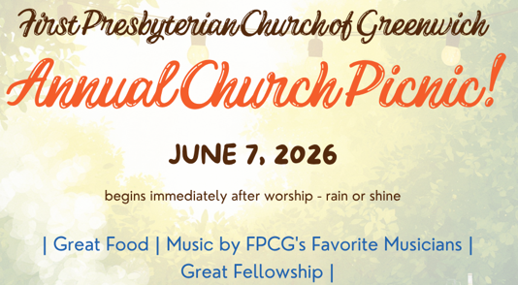

\

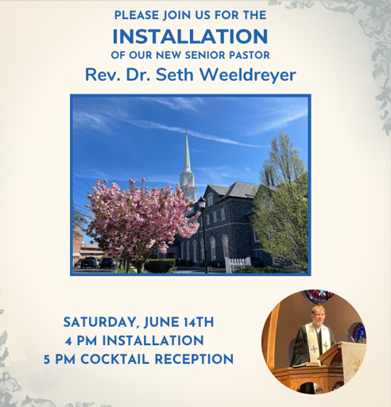

STEWARDSHIP: The 2026 Generosity Challenge
“Be Generous and Willing to Share” (1 Tim. 6:18)
We are currently in the midst of our Generosity Challenge. Our goal is to greet our new leadership with a "good foundation" for the future by reversing the downward drift in our average pledge. We are challenging every household to pray about moving "one step up" into a new Generosity Circle: Covenant Circle ($1,000), Cornerstone Circle ($2,500), Stewardship Circle ($5,000), Deacon’s Circle ($10,000), Pastor’s Circle ($15,000), Apostle’s Circle ($25,000), or Knox Circle ($50,000).

Progress Update:
- Total Pledges Received: 137
- Total Amount Committed: $1,097,448
- Progress Toward Our Goal: 84%

Remember, these Circles are not for public recognition; they are a private commitment between you and God. I know the levels, you know your heart, and God knows our needs. If you haven't yet turned in your pledge, please join us as we build this foundation together.

To pledge, visit church’s website: www.fpcg.org/2026stewardship
Email the Elder for Stewardship, Brian Pennington, at stewardship@fpcg.org
Email Director of Operations, Erin Moore, at erin@fpcg.og or call 203 869 8686 ext. 123.
FPCG COMMUNICATIONS
HOW DO YOU FEEL ABOUT FPCG?
All FPCG communications -- website, social media presence, bulletin, First Press, etc. -- should reinforce a unified message that matches our values. This messaging, if effective, should stimulate a positive emotional response, which, in turn is intended to stimulate engagement and congregational growth.

A steering committee is working on what this might mean for a redesign of our communications. This committee seeks input from the congregation. Please complete a simple survey by scanning the QR code. It includes only 2 simple questions and will take 1-2 minutes to complete.

We will also have further discussion about this after worship on Sunday, May 31 in Fellowship Hall – Centering and Imagining with Pastor Seth. Stay tuned. For more information, contact Sandy Waters, Elder for Communications at swimwaters@gmail.com.
CONNECT WITH MEMBERS: USE THE CHURCH DIRECTORY!!
Do you want to

  - call another FPCG member on the phone?
  - send an email to someone you met at church?
  - send a note of sympathy or a Christmas card to a church friend?
  - update or correct your church information?
  - add a photo to your Profile?
Check out the Church Directory on the church website, www.fpcg.org. Click on the About tab, then Member Resources, and then Directory. Use your email address as a USER NAME and create a PASSWORD to gain access.

LEADERSHIP
Session
Rev. Dr. Seth E. Weeldreyer, Senior Pastor
Rev. Andre Castillo, Associate Pastor
Michelle Binnie, Clerk of Session
Philip Carrone Liz James Elizabeth Peyton
Delano Copprue Jim Joyella Lori Mulcare
Lilian Eng Ryan Kim Stephanie Schnabel
Lee Ganshaw Kimberly Lee Sue Sproule
Layne Grindal Brian Pennington Sandy Waters
Session members may be contacted at session@fpcg.org. Messages go to all Session members.

Board of Deacons
Julie Mather, Moderator
Wayne Atwell Jennifer Dott Betsy Harper
Renie Blair Bob Giambo Barbie McKelvey
Diane Brown Carolyn Hahn-Re Judith Riggs
Margaret Copprue Liz Harden Catherine Stahl
Deacons may be contacted at deacons@fpcg.org. Messages go to all deacons.

Clergy & Staff Contacts
Rev. Dr. Seth E. Weeldreyer, Senior Pastor seth@fpcg.org Ext. 115
Rev. Andre Castillo, Associate Pastor andre.castillo@fpcg.org Ext. 119
Dr. Caroline Worra, Minister of Music caroline.worra@fpcg.org Ext. 120
Tara Church, Director, Children’s Ministries tara@fpcg.org Ext. 118
Heather Antonissen, Director, Bell Choirs heather.antonissen@fpcg.org
Jestin Pieper, Organ Associate jestin.pieper@gmail.com
Erin Moore, Director of Operations erin@fpcg.org Ext. 123
Randy Ante, Facilities Manager randy.ante@fpcg.org Ext. 114
Rommel Espano, Sexton rommel.espano@fpcg.org Ext. 112
Jane Parker, Bookkeeper jane@fpcg.org Ext. 128
Linda DiMarino, Office Administrator officeadmin@fpcg.org Ext. 110
Megan Florentine, Director, Nursery School megan.florentine@fpcgns.org (203) 869-7782

Ministers: All members of the congregation.
FIRST PRESBYTERIAN CHURCH OF GREENWICH
One West Putnam Avenue · Greenwich, Connecticut 06830
www.fpcg.org · (203) 869-8686



We are a Stephen Ministry Church.

