FIRST PRESBYTERIAN CHURCH
OF GREENWICH

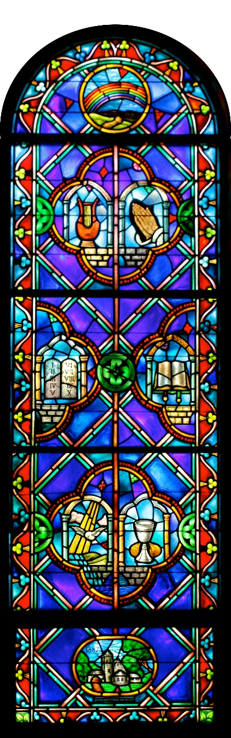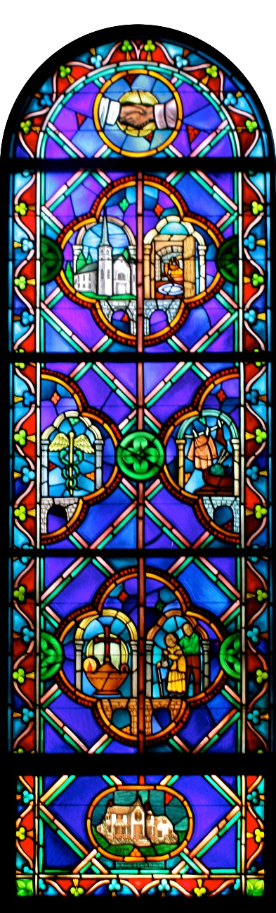

Confirmation Sunday
May 17, 2026
10:00 AM

Wherever you are on life’s journey, you are welcome here—with whatever joys, questions, or tears you
bring today—as we worship God, who welcomes us all! You are invited to listen for God’s Spirit
speaking through the music of the Prelude as we prepare our hearts for worship.

ORDER OF WORSHIP
PRELUDE |  |  |  |  | Prelude on Hyfrodol  Jesse Pieper, organ |  |  |  |  |  |  | R. V Williams  (1872-1958)
WELCOME |  |  |  | The Rev. Andre Castillo
*CALL TO WORSHIP
 |  | One: |  | Jesus asked his disciples, "Who do people say that the Son of Man is?" And they said…
 |  | All: |  | "Some say John the Baptist, but others Elijah, and still others Jeremiah or one of the prophets."
 |  | One: |  | Jesus said to them, "But who do you say that I am?" Simon Peter answered…
 |  | All: |  | "You are the Messiah, the Son of the living God."
 |  | One: |  | And Jesus answered him, "Blessed are you, Simon son of Jonah! For flesh and blood has not revealed this to you, but my Father in heaven. And I tell you, you are Peter, and on this rock I will build my church, and the gates of Hades will not prevail against it."
 |  | All: |  | We are the Church – praise be to God!
*HYMN 12 |  |  |  |  |  | Immortal, Invisible, God Only Wise |  |  |  |  | ST. DENIO
*CALL TO CONFESSION
*Prayer of CONFESSION
 |  | All: |  | Holy God, you invite us to follow you, yet our hearts wander astray. You call us to lives of service, yet our hands lay idle. You commission us to share the Good News, yet our mouths are full of gossip and malice. As we recall the many ways in which we have fallen short of your vision for our lives, we also recall your abundant mercies, which cover us anew every morning. Forgive us, Lord, and lead us back to the Way of faith, hope, and love.
*ASSURANCE OF FORGIVENESS
 |  | One: |  | Hear the Good News: Jesus Christ did not come into the world to condemn the world, but so that the world might be saved through him. By his love and sacrifice, we are forgiven, and set free to live the abundant life he has promised.
 |  | All: |  | Thanks be to God, Amen!
*RESPONSE OF PRAISE GLORIA PATRI
Glory be to the Father, and to the Son, and to the Holy Ghost;
as it was in the beginning, is now, and ever shall be, world without end. Amen, Amen.

*PASSING THE PEACE OF CHRIST
TIME FOR YOUNG DISCIPLES |  |  |  |  |  |  |  |  |  |  | Tara Church
SACRAMENT OF BAPTISM

Caroline & Pierce Poznyakov
(Children of Katie & Vlad Poznyakov)
Lexi & Tilli Warren

Presentation Liz James, Elder
Thanksgiving over the Water
Baptism
Welcome

PRAYER FOR ILLUMINATION Morgan Schwartzstein
 |  | All: |  | Gracious God, we gather in your holy presence in order that we might hear your voice and be led in your Way. To that end, may the words of our mouths and the meditations of our hearts be acceptable in your sight, O Lord, our Rock and our Redeemer. Amen.
SCRIPTURE |  |  |  |  |  | John 17:1-11 |  |  |  |  | p. 111 NT
ANTHEM |  |  |  |  |  | With a Voice of Singing  Chancel Choir  Jesse Pieper, organ |  |  |  |  | Martin Shaw  (1875-1958)
 | With a voice of singing declare ye this and let it be heard, Alleluia! Utter it even unto the ends of the earth. The Lord hath delivered his people, Alleluia! O be joyful in God, all ye lands, O sing praises to the honor of his name, make his praise to be glorious!
SCRIPTURE |  |  |  |  |  | Acts 1:6-14 |  |  |  |  | p. 118 NT
 |  | One:  All: |  | For the Word of God in Scripture, for the Word of God among us,  for the Word of God within us, alive in our hearts,  Thanks be to God.
SERMON |  |  |  |  |  | What Do We Do Now? |  |  |  |  | Rev. Andre Castillo
*AFFIRMATION OF FAITH 1 Peter 4-5
 |  | All:
  Beloved, we are not surprised at the fiery ordeal that is taking place among us to test
  us, as though something strange were happening to us. But we rejoice insofar as we are
  sharing Christ’s sufferings, so that we may also be glad and shout for joy when his glory
  is revealed. We humble ourselves therefore under the mighty hand of God, so that he may exalt us
  in due time. We cast all our anxiety on him, because he cares for us. We discipline
  ourselves, keeping alert. And after we have suffered for a little while, the God of all grace, who has called us to his eternal glory in Christ, will himself restore, support, strengthen, and establish us.
  To him be the power forever and ever. Amen.
MOMENT FOR STEWARDSHIP |  |  |  |  |  |  |  |  |  |  | Brian Pennington, Elder
HYMN 463 |  |  |  |  |  | How Firm a Foundation  vs. 1, 2, 5 |  |  |  |  | FOUNDATION
SERVICE OF CONFIRMATION Ryan Kim, Elder

Presentation of the Confirmands

Breit Delany | Elsa Kim | Ainsley Sorenson
Maddie Guarnera | Nina Loverro | Lexi Warren
Mila Hager | James McCallen | Tilli Warren
Coco Hochman | Hudson McWhorter
Fischer Hogan | Morgan Schwartzstein

Statement of Purpose
Questions of Membership
Prayer with the Laying on of Hands
(Families of the Confirmands are invited to come forward for the laying on of hands.)
OFFERING
Ritual of Friendship: Please sign the red fellowship pad in your pew and pass it to your neighbor.
OFFERTORY SOLO |  |  |  |  |  | Fur Elise  Breit Delany, piano |  |  |  |  | Ludwig van Beethoven  (1770-1827)
*DOXOLOGY
Praise God, from whom all blessings flow; Praise God, all creatures here below.
Praise God above, ye heavenly host; Praise Father, Son and Holy Ghost. Amen
*PRAYER OF DEDICATION
 |  | All: |  | Gracious God, for all your gifts, both seen and unseen, we give you thanks. May our offerings be acceptable in your sight; a mere portion of what you have so generously given to us. We pray that you would do more with them than we could ever ask or imagine. In Christ’s name we pray, Amen.
*HYMN 69 |  |  |  |  |  | Here I Am, Lord |  |  |  |  | HERE I AM (Schutte)
*CHARGE AND BLESSING
POSTLUDE |  |  |  |  |  | Toccata  Jesse Pieper, organ |  |  |  |  | J. Rutter  (b. 1945)
*We are invited to rise together in God’s Spirit.

WELCOME!
We are delighted you are joining us in worship! Founded on Easter Sunday in 1881, First Presbyterian Church of Greenwich embraces our mission to nurture and empower people in all stages of life to be Christ’s disciples and to actively serve those in need. All children are invited to stay in worship and join us on the steps during Time for Young Disciples. Childcare is available for those who are three years and younger in room 350.
SERVICE PARTICIPANTS
Rev. Andre Castillo; Dr. Caroline Worra, Music Minister; Tara Church, Director of Children’s Ministry; Jesse Pieper, organ/piano; Chancel Choir; Britt Delany, solo; Morgan Schwartzstein, reader; Brian Pennington, elder; Liz James, elder; Ryan Kim, elder.

Pastor Seth will be away leading CREDO, a conference for clergy wellness in our Presbyterian Church (USA). He will return to the office on Tuesday, May 19.

Team 4: Mathew Lorig (Captain), Helen Ji (Deputy), Jonathan Larken, Julie Lorig, Eleanor Lorig, Timmy & Brian Lorig, Caroline Peyton, Elizabeth Peyton, Judy Soto, David Zadik..
PRAYERS OF THE PEOPLE
Our siblings locally and abroad who are living in areas torn by natural disasters and war; Dimitrios Apostolou, John & Martha Awdziewicz, the Campbell Family, Cassandra Fountain, Laura Eskandar, the Hampton Family, Carolyn Hopley, Susie Huang, Bev Jomo, Cadwallader K., Ann Koontz, Ki Lee, Kimber Lee, the McKelvey Family, Eric Moy, the Nicholas Family, Adrienne & Don Perry, the Raker families and the Spada family, Charlene Roberson, Elly Schafer and Mike Long.
JOIN US TODAY IN FELLOWSHIP HALL FOLLOWING THE SERVICE
There will be a reception of our Confirmation class, as well as baptism celebration for the Katie & Vlad Poznyakov family.
WOMEN’S BOOK GROUP
Join us for fellowship and book discussion in the Church Library on the 4th Floor. We gather at 9:15 a.m. for coffee and discussion starts at 9:30 a.m. Contact Colleen Giambo at cgiambo@gmail.com for further information. Here is the upcoming Women's Book Group selection:
June19 When We Cease to Understand the World, by Benjamin Labatu
PILGRIMAGE TO IONA ABBEY

Pastor Seth will lead a pilgrimage to Iona Abbey! Dates: August 26 – September 6, 2026. The centerpiece will be living in the Abbey for a week, sharing worship, conversation, and other rhythms of life and faith in that ancient “thin place.” On the way out to the Isle of Iona (western Scotland) we’ll experience other sites of historical and spiritual significance, all as a catalyst for us to consider how we live faithfully in our time and place. Scan the QR code for additional information and registration form.
MISSION ENGAGEMENT
Pacific House Cooks: Join the FPCG team to cook and serve meals for men and young male residents of Pacific House on the second Thursday of every month. Cook in the FPCG kitchen from 1:30 to 4:30 p.m. or serve at Pacific House from 5:30 to 6:30 p.m. Contact Carol Barber: cbarber@cyburban.com or at (914) 490-6621.
Drivers Needed for Call-A-Ride: Have a few hours a week to assist elderly members of our
community? Drivers are needed and riders are welcome!
If you are in need of our services, either as a rider or volunteer please reach out to us:
Facebook Call A Ride +1 203 661 6633
We have provided 8000 drives for 369 individuals in the past year. You can now follow us on Facebook.

CENTERING AND IMAGINING WITH PASTOR SETH
As we live into months and years ahead, let’s share appreciation and vision for our life together! Two questions:
What inspires us in our life together—makes us feel Holy Love moving within / among us?
What do we aspire to be and do together within our congregation and serving our community and beyond? We’ll gather in Fellowship Hall after worship on May 31, beginning this open conversation at 11:30. Our thoughts will help center our disparate endeavors and catalyze work on communications / marketing / branding efforts moving forward. Hope to see you and hear your voice as we listen to one another, honoring and energizing life we share.
ADULT EDUCATION
Sunday, May 24, 11:30 a.m. - The Library - The State of Play: End-of-Life Care in the United States
What is an advanced directive? What differentiates end-of-life care in the Unites States and Canada? How is grief a form of love? Join Academy after Worship for a presentation by and conversation with Annapurna Sinha, MBE in the Library
Saturday, June 6, Time: TBA - Metropolitan Museum of Art -Raphael: Sublime Poetry
On Saturday, 6 June, join the Adult Education Committee for a visit to the Raphael: Sublime Poetry exhibition, followed by a lunch and conversation with a museum docent. Registration details to follow.
PARENTS’ BIBLE STUDY
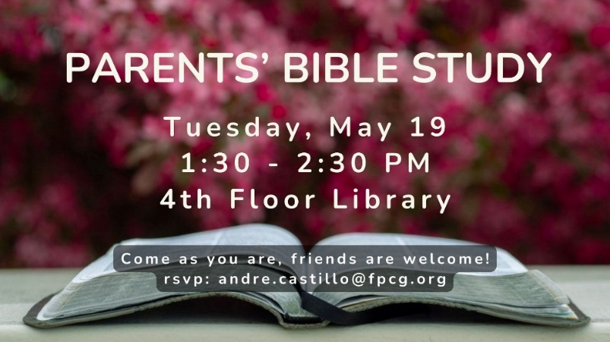

FPCG COMMUNICATIONS
HOW DO YOU FEEL ABOUT FPCG?
All FPCG communications -- website, social media presence, bulletin, First Press, etc. -- should reinforce a unified message that matches our values. This messaging, if effective, should stimulate a positive emotional response, which, in turn is intended to stimulate engagement and congregational growth.

A steering committee is working on what this might mean for a redesign of our communications. This committee seeks input from the congregation. Please complete a simple survey by scanning the QR code. It includes only 2 simple questions and will take 1-2 minutes to complete.

We will also have further discussion about this after worship on Sunday, May 31 in Fellowship Hall – Centering and Imagining with Pastor Seth. Stay tuned. For more information, contact Sandy Waters, Elder for Communications at swimwaters@gmail.com.

STEWARDSHIP: The 2026 Generosity Challenge
“Be Generous and Willing to Share” (1 Tim. 6:18)
As we move closer to welcoming our new Senior Pastor in April, we are currently in the midst of our Generosity Challenge. Our goal is to greet our new leadership with a "good foundation" for the future by reversing the downward drift in our average pledge. We are challenging every household to pray about moving "one step up" into a new Generosity Circle: Covenant Circle ($1,000), Cornerstone Circle ($2,500), Stewardship Circle ($5,000), Deacon’s Circle ($10,000), Pastor’s Circle ($15,000), Apostle’s Circle ($25,000), or Knox Circle ($50,000).

Progress Update:
- Total Pledges Received: 136
- Total Amount Committed: $1,081,403
- Progress Toward Our Goal: 83%

Remember, these Circles are not for public recognition; they are a private commitment between you and God. I know the levels, you know your heart, and God knows our needs. If you haven't yet turned in your pledge, please join us as we build this foundation together.

To pledge, visit church’s website: www.fpcg.org/2026stewardship
Email the Elder for Stewardship, Brian Pennington, at stewardship@fpcg.org
Email Director of Operations, Erin Moore, at erin@fpcg.og or call 203 869 8686 ext. 123.

SPRING LUNCHEON
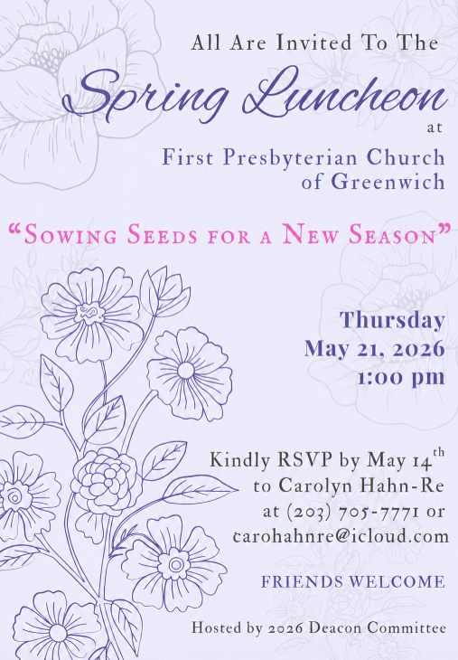
LEADERSHIP
Session
Rev. Dr. Seth E. Weeldreyer, Senior Pastor
Rev. Andre Castillo, Associate Pastor
Michelle Binnie, Clerk of Session
Philip Carrone Liz James Elizabeth Peyton
Delano Copprue Jim Joyella Lori Mulcare
Lilian Eng Ryan Kim Stephanie Schnabel
Lee Ganshaw Kimberly Lee Sue Sproule
Layne Grindal Brian Pennington Sandy Waters
Session members may be contacted at session@fpcg.org. Messages go to all Session members.

Board of Deacons
Julie Mather, Moderator
Wayne Atwell Jennifer Dott Betsy Harper
Renie Blair Bob Giambo Barbie McKelvey
Diane Brown Carolyn Hahn-Re Judith Riggs
Margaret Copprue Liz Harden Catherine Stahl
Deacons may be contacted at deacons@fpcg.org. Messages go to all deacons.

Clergy & Staff Contacts
Rev. Dr. Seth E. Weeldreyer, Senior Pastor seth@fpcg.org Ext. 115
Rev. Andre Castillo, Associate Pastor andre.castillo@fpcg.org Ext. 119
Dr. Caroline Worra, Minister of Music caroline.worra@fpcg.org Ext. 120
Tara Church, Director, Children’s Ministries tara@fpcg.org Ext. 118
Heather Antonissen, Director, Bell Choirs heather.antonissen@fpcg.org
Jestin Pieper, Organ Associate jestin.pieper@gmail.com
Erin Moore, Director of Operations erin@fpcg.org Ext. 123
Randy Ante, Facilities Manager randy.ante@fpcg.org Ext. 114
Rommel Espano, Sexton rommel.espano@fpcg.org Ext. 112
Jane Parker, Bookkeeper jane@fpcg.org Ext. 128
Linda DiMarino, Office Administrator officeadmin@fpcg.org Ext. 110
Megan Florentine, Director, Nursery School megan.florentine@fpcgns.org (203) 869-7782

Ministers: All members of the congregation.
FIRST PRESBYTERIAN CHURCH OF GREENWICH
One West Putnam Avenue · Greenwich, Connecticut 06830
www.fpcg.org · (203) 869-8686



We are a Stephen Ministry Church.

